3.Write a Pandas program to display the details of jobs in descending sequence on job
title.
Program:
import pandas as pd
# Create Jobs dataset
jobs = pd.DataFrame({
"Job_ID": [1, 2, 3, 4, 5],
"Job_Title": [
"Data Scientist",
"Software Engineer",
"Database Administrator",
"AI Engineer",
"Web Developer"
],
"Min_Salary": [50000, 45000, 40000, 55000, 35000],
"Max_Salary": [90000, 85000, 75000, 95000, 70000]
})
print("Original Jobs Dataset:")
print(jobs
# Sort jobs by Job Title in descending order
result = jobs.sort_values(by="Job_Title", ascending=False)
print("\nJobs in descending order of Job Title:")
print(result.to_string(index=False))
Output:
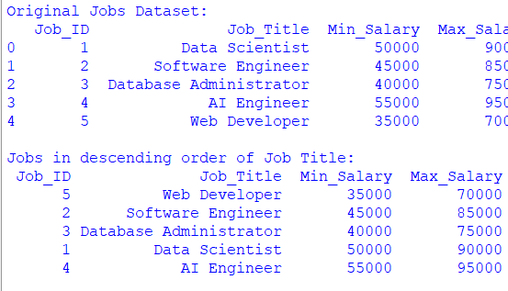

4.Write a Pandas program to create a line plot of the historical stock prices of Alphabet
Inc. between two specific dates.
Program:
import pandas as pd
import matplotlib.pyplot as plt
# Create Alphabet stock dataset
stock_data = pd.DataFrame({
"Date": pd.to_datetime([
"2024-01-01",
"2024-02-01",
"2024-03-01",
"2024-04-01",
"2024-05-01",
"2024-06-01",
"2024-07-01",
"2024-08-01"
]),
"Close": [140, 145, 150, 155, 160, 158, 165, 170],
"Volume": [1000000, 1200000, 1100000, 1400000,
1300000, 1500000, 1600000, 1700000]
})
# Select dates between two specific dates
start_date = "2024-01-01"
end_date = "2024-08-01"
filtered_data = stock_data[
(stock_data["Date"] >= start_date) &
(stock_data["Date"] <= end_date)
]
# Create line plot
plt.figure(figsize=(10, 5))
plt.plot(
filtered_data["Date"],
filtered_data["Close"],
marker="o"
)
plt.title("Alphabet Inc. Historical Stock Prices")
plt.xlabel("Date")
plt.ylabel("Closing Price")
plt.xticks(rotation=45)
plt.grid(True)
plt.tight_layout()
plt.show()
Output:
